Practical - 10
Practical Title: Secure Login/Logout with Sessions, Role-Based Access, Timeout, and Remember-Me Token
Problem Definition: Develop secure login and logout functionality using PHP sessions. Verify password using password_verify(), regenerate session ID after login, restrict dashboard access, implement role-based redirection, session timeout, and optional secure remember-me token.

Theory :
1. Are sessions started and destroyed securely?

Yes, your StudentHub project uses session_start() to start sessions, session_regenerate_id(true) after login, and session_unset() with session_destroy() during logout or session timeout to clear session data securely.

2. Is password_verify() used correctly?

Yes, your StudentHub login uses password_verify($password, $user["password"]) to compare the entered password with the hashed password stored in MySQL.

3. Is unauthorized dashboard access blocked?

Yes, unauthorized dashboard access is blocked if your dashboard.php checks $_SESSION["user_id"] and redirects users who are not logged in to login.php. Admin pages should also verify the user's role.

Implementation/ Output/Result
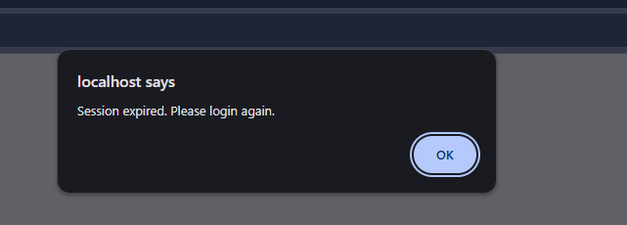

GitHub Repository Link:

https://github.com/rushiaghara25/StudentHub-Portal-2.git

Learning Outcomes:

Implemented secure login and logout using PHP sessions.

Verified passwords using password_verify().

Restricted dashboard access to authenticated users.

Implemented role-based access for students and administrators.

Added session timeout and secure session ID regeneration.

Improved authentication security and session management.

Faculty Remarks: (Keep this blank for faculty)

